# 001. Code in Mins-LaunchPad-1-How to create the tile and configure the launchpad

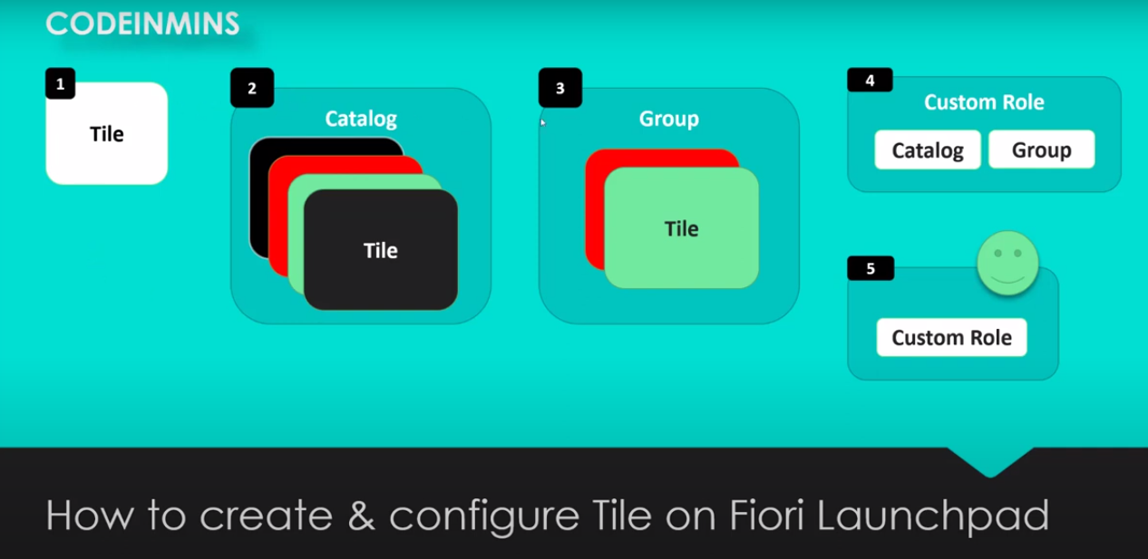

Tile:

-- is nothing but a block and it is starting point to the application to launch on fiori launch pad.

Catalog:

-- Catalog refers to the collection of multiple tiles available in your systems

Group:

-- is also collection of tiles, but those tile can be separated by other available tiles in the system. we group different tiles then they can be segregated by the other tiles.

Custom Role:

-- We need to create the custom role, that role we can assign the catalog and group.

Custom role assign to the user:

-- Once role created, then custom role assigned to the specific use, when the user has assigned the role then user will be to see the fiori lunchpad group and associated tile inside the group.

above the steps are used for perform to get the fiori tile on fiori launchpad with application running.

Note : catalog and group are obsolute now. Now concept available from S4Hana-2020 is "PAGES" and "SPACES". we will see, how those things work.

## How to send the application Fiori LaunchPad:

Information: WEBIDE and FIoriLauncpad locally config

1. create the application.

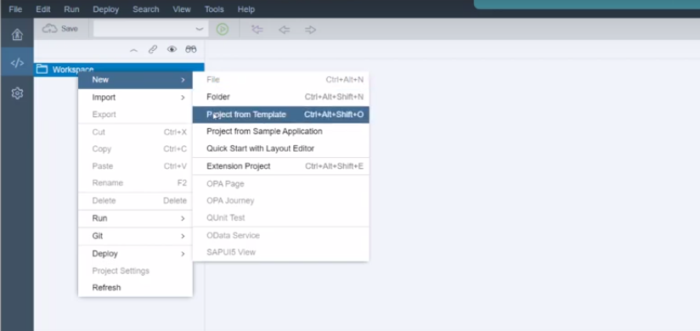 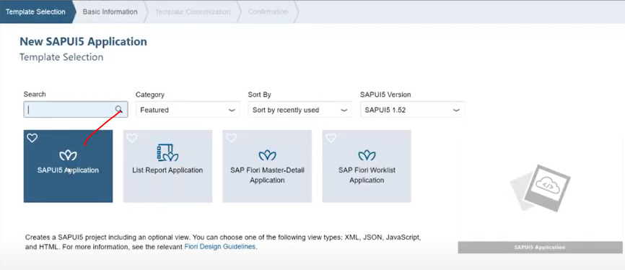

click on next

provide project name and name space.

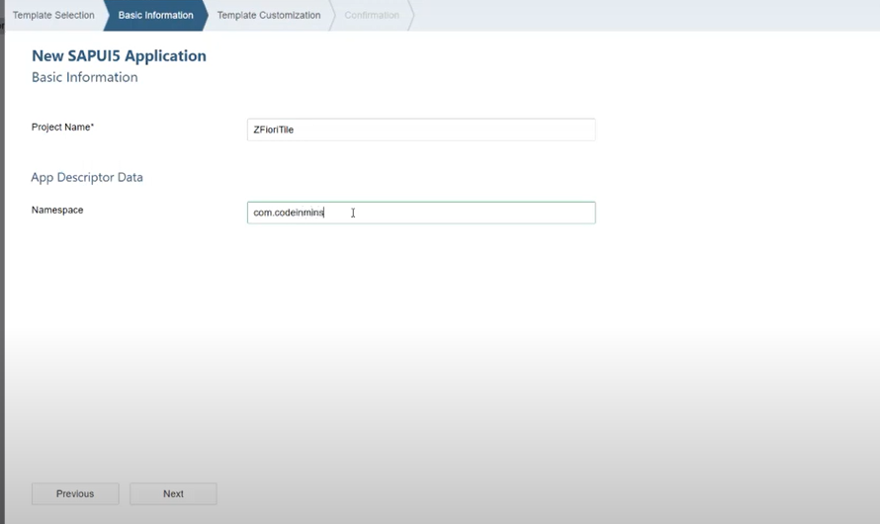

click on next

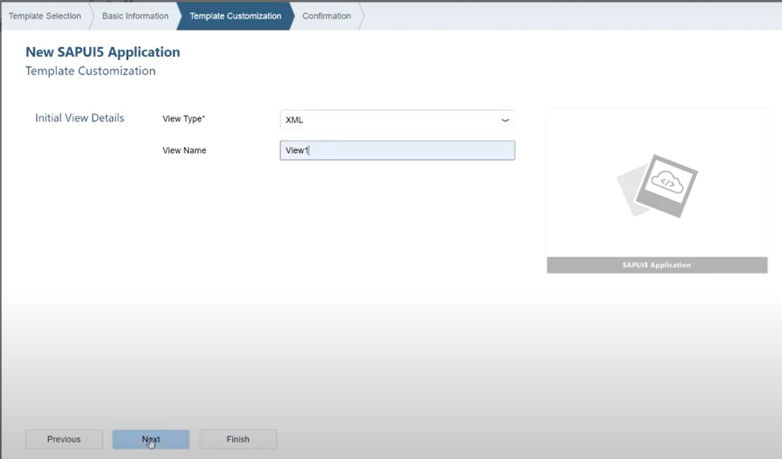

click on next

click on finish.

Now application, ready in webide

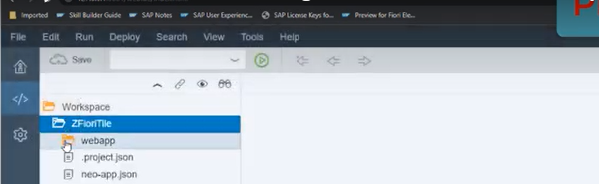

add the ui element in View1

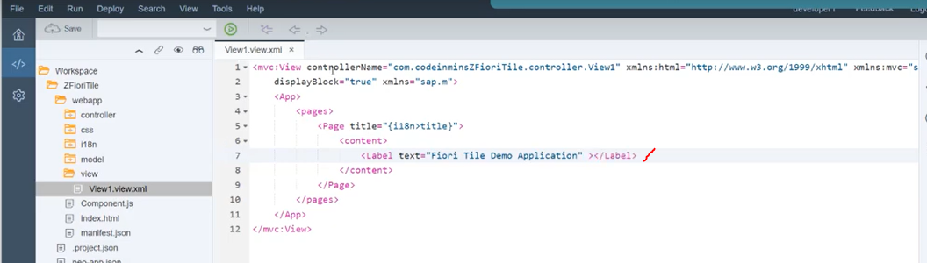

RUN application.

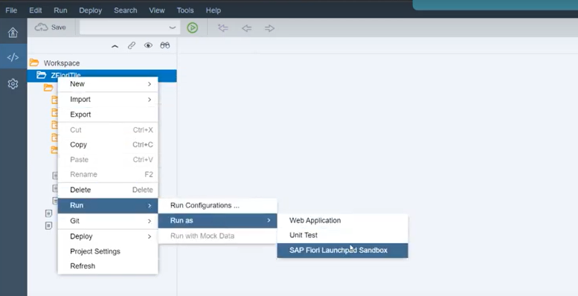

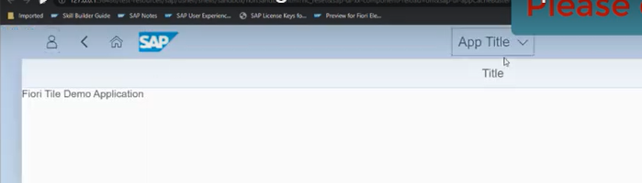

Now application is ready, we go the output too...

## Send application to the server(abap backend system)-Deployment

1. Select the project -->right click it -->click on deploy -->Deploy to SAP ui5 repository.

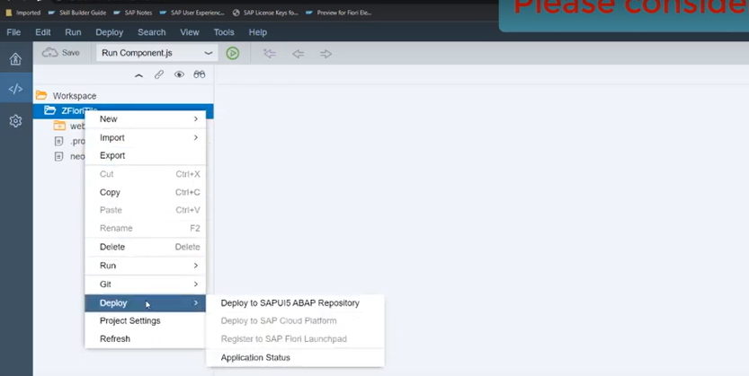

as soon as click on that in the system<--whatever system will have configured those system appears in dropdown.

2. Select the system--> click on next

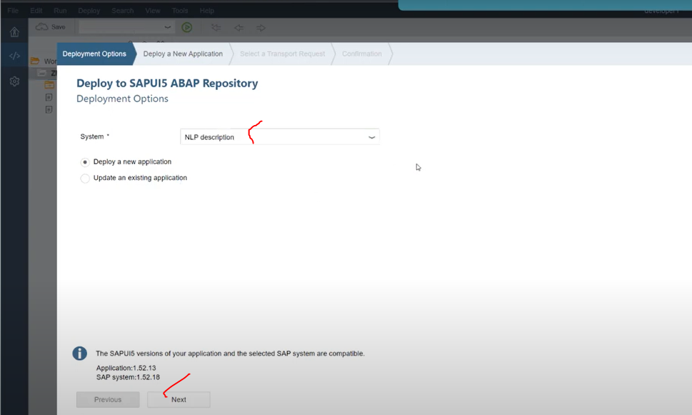

For first time deploying the app-->Deploy a new application

changes to choose the -->Update on Existing app.

3. provide name: --> identified inside the sicf node.

Provide the description/package

click on NEXT

4. Select the TR --> click on next

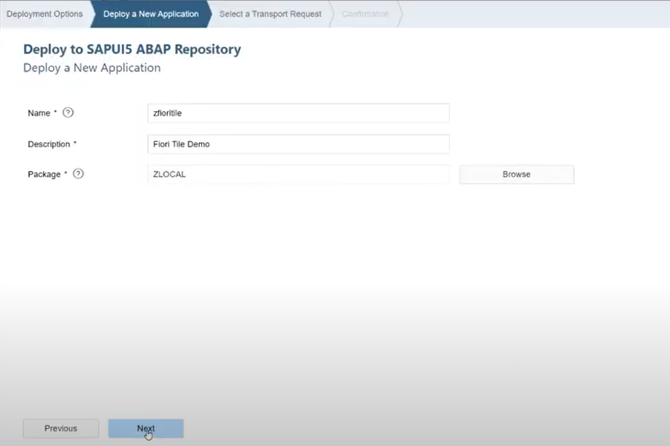

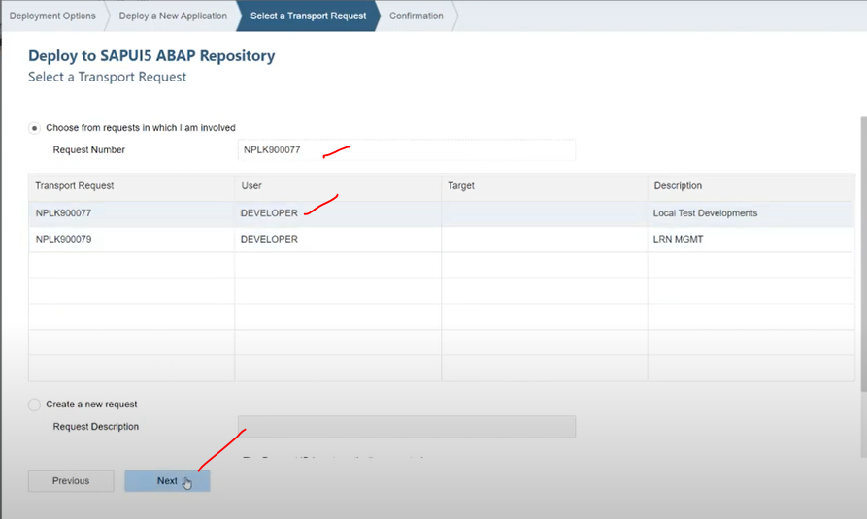

click on next --> click on finish

so our app deployed in server.

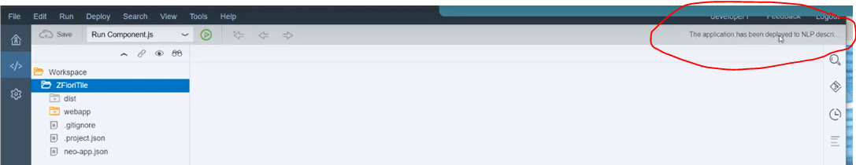

once you will get the message, you can able to see the folder "dist" folder inside the application-webide.

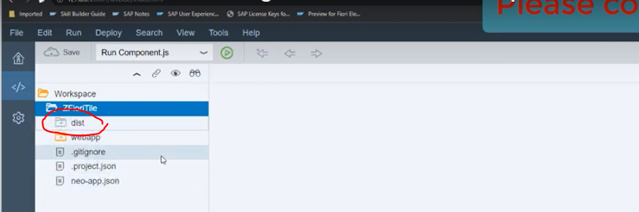

once deplyed.. lets go to the abap server, need to see where it has deployed..

## Deployed apps check it in SICF system

1. login abap system

2. Go SICF tcode

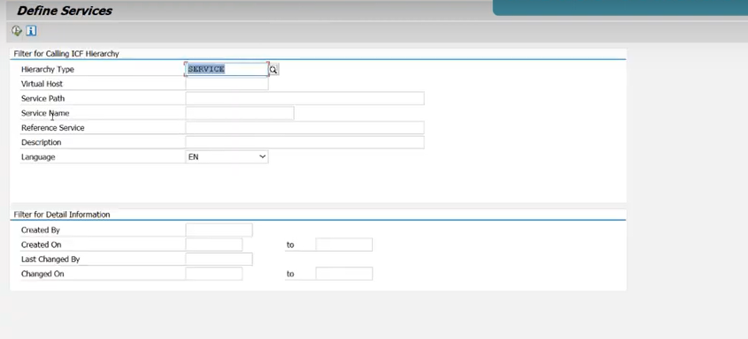

app deployed in below path: sap/bc/ui5_ui5/sap/ <-- in these path you will able to see all the applications(deployed).

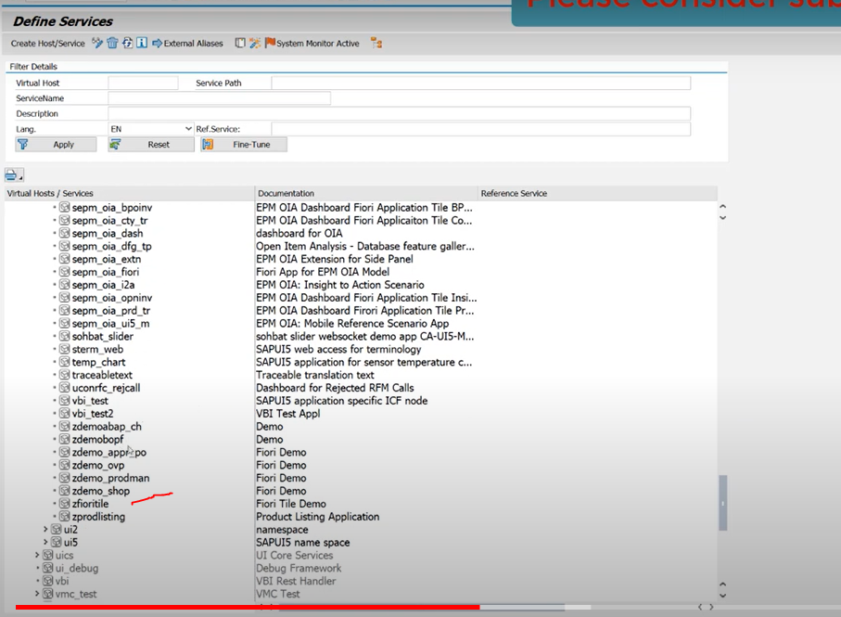

## now we will config app(Zfioritile) to fiori launchpad.

1. Now open the fiori launchpad in browser using url

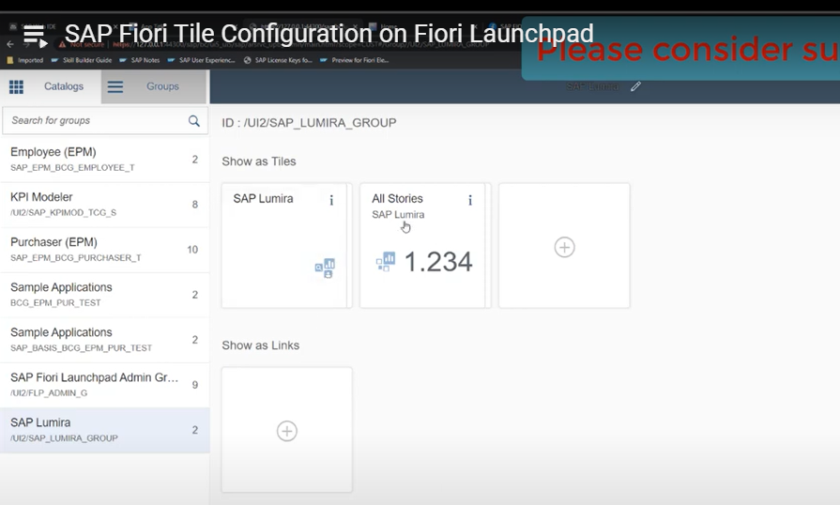

Now we are able to see the catalog and groups

Now create the new catalog/ click on catalog tab and click on + button in master list.

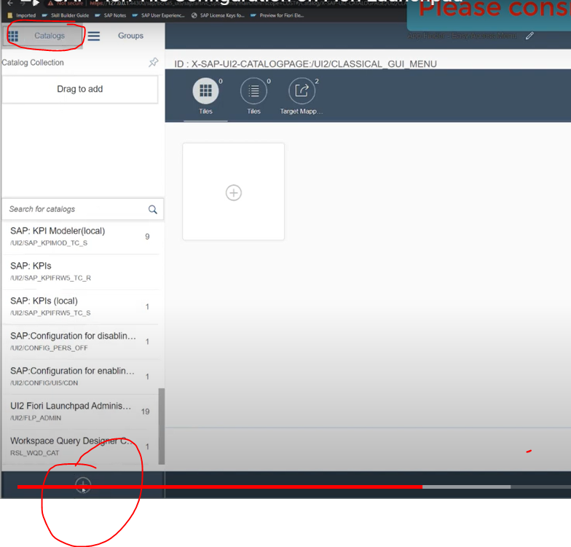

you will get the popup, lets create the Title and Id.

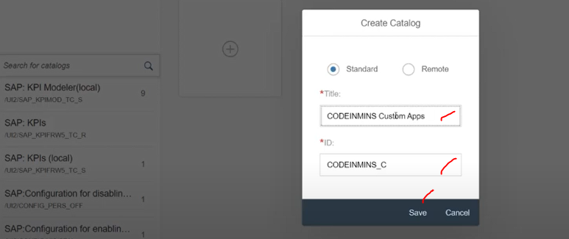

click on SAVE, it will appear in the catalog tab.

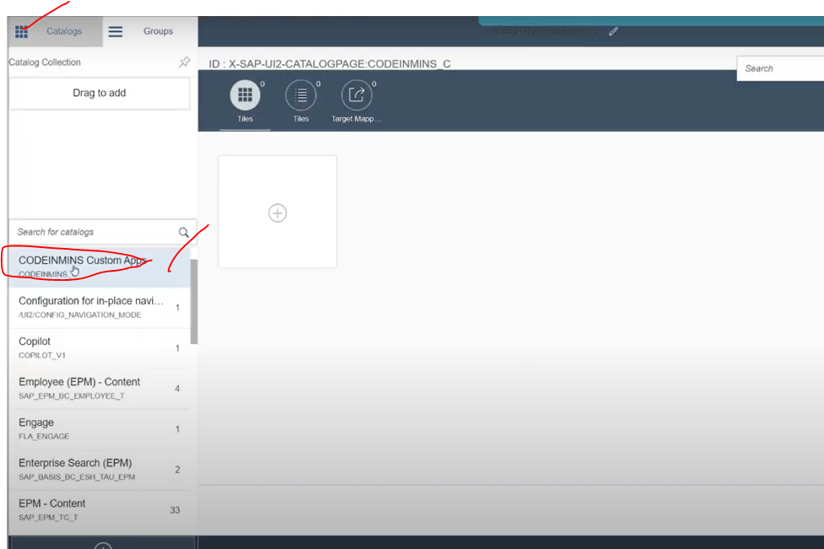

Now create the Group--> click on groups tab.--> click on + button under master list.

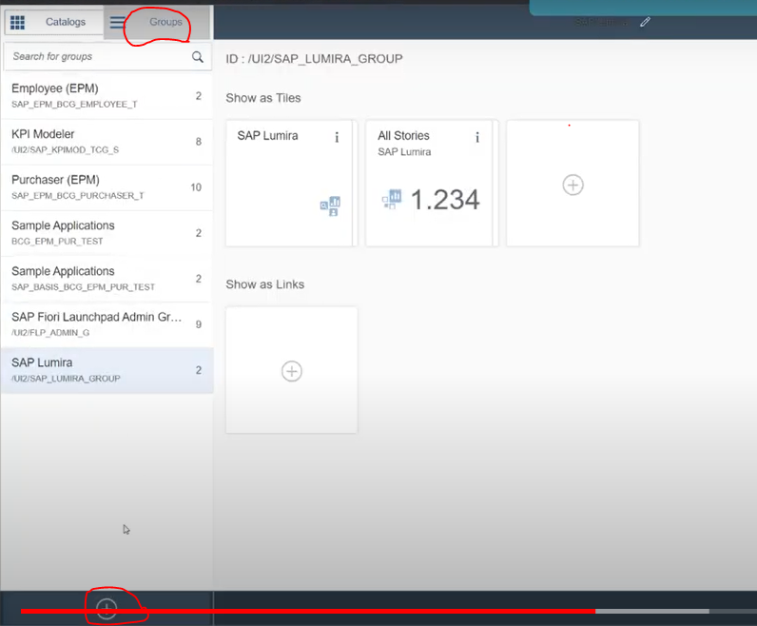

Next popup, provide group title and id

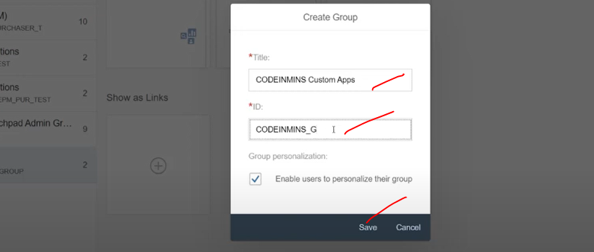

Now it appears in group tab.

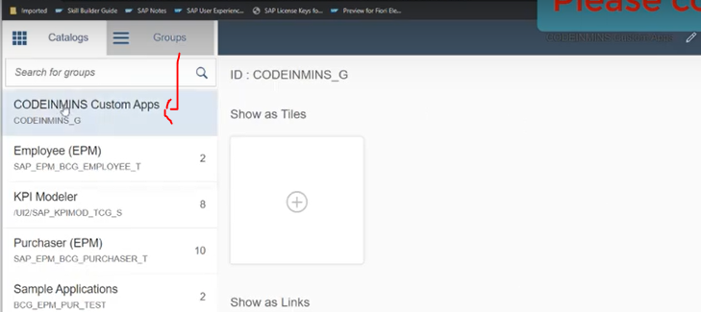

Now Group and Catalog has been created.

## Now we need to add our app to catalog

Select the catalogs tab --> select the created catalog--> click on tiles button in right side screen.

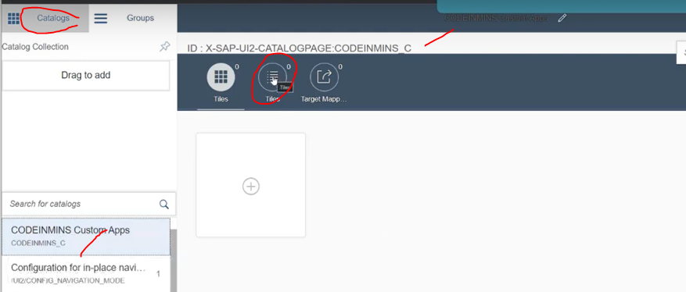

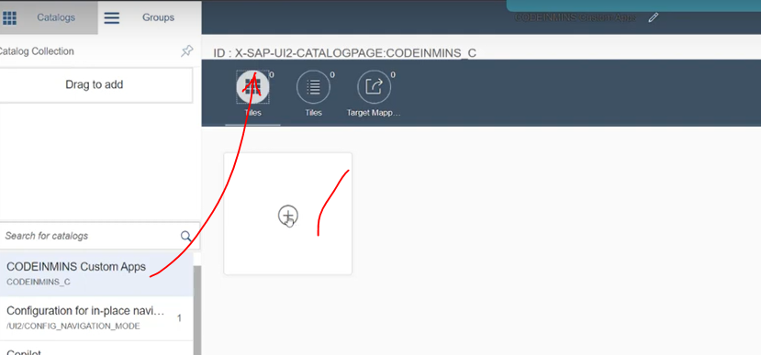

click on + button- right side

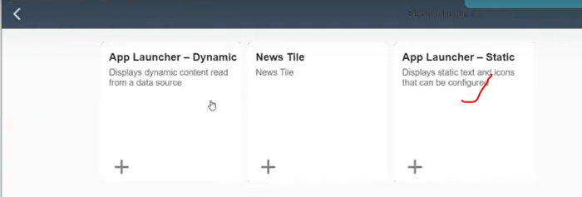

click on Static tile

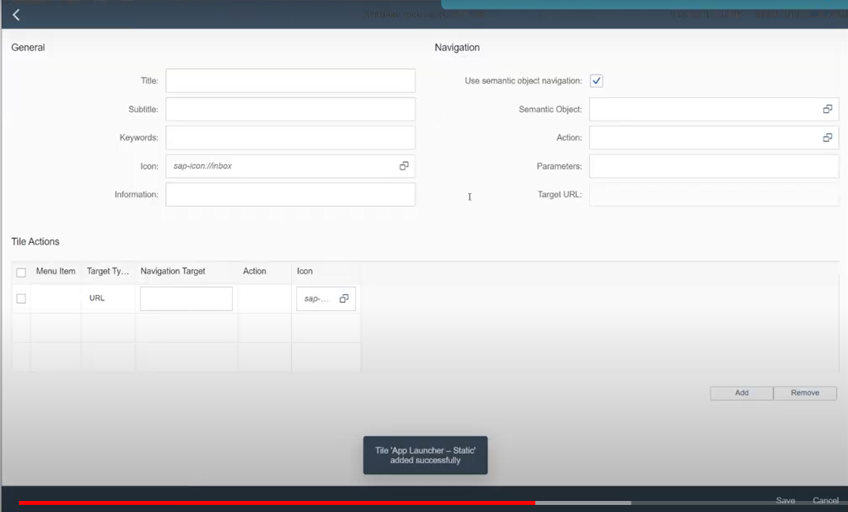

Provide title/icon and provide the semantic object:

sematic object needed when app launching to fiori LPAD.

to create the sematic object: /ui2/semobj

open the tcode :/ui2/semobj

provide : sematic obj/sematic obj description/semantic object name

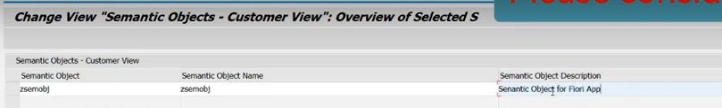

save in customize request.

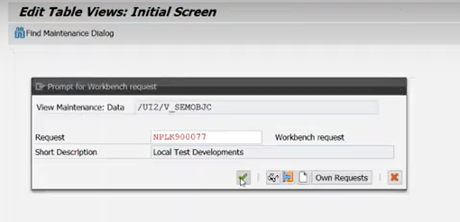

Now sematic object created here...

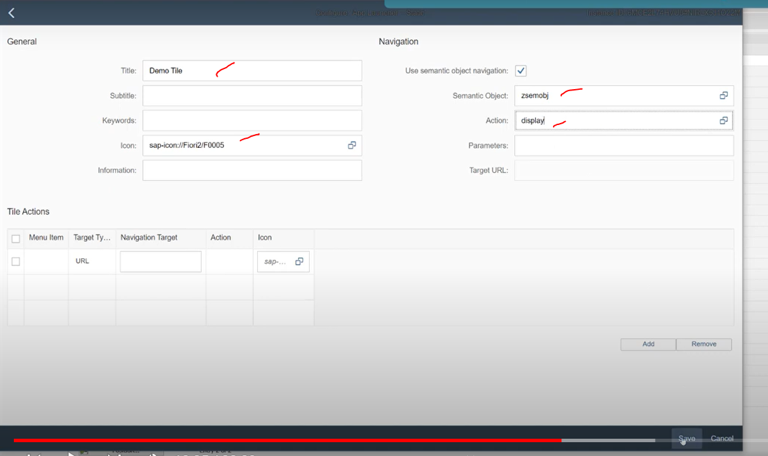

click on SAVE

Now tile has been created

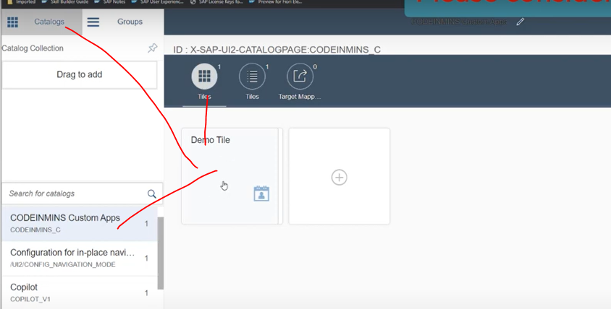

Target-URL: sematic object + Action

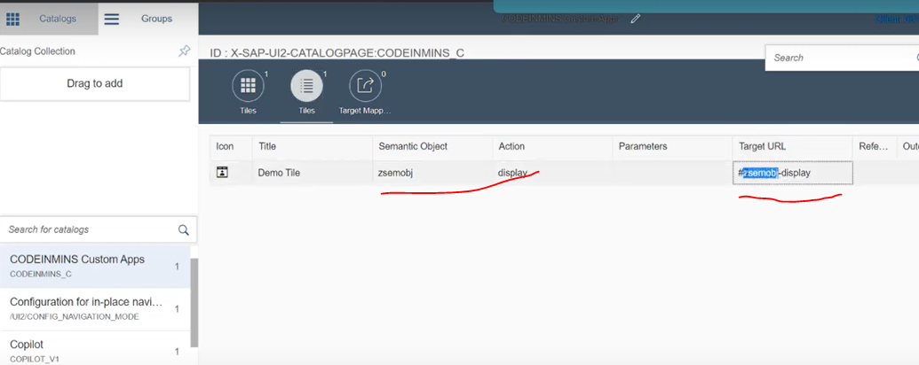

Navigation could be done with target-url

Now we will do the "Target-Mapping"

Target mapping: what application to open, when click on this tile.

Click on Target Mapping.--> Click on create Target Mapping

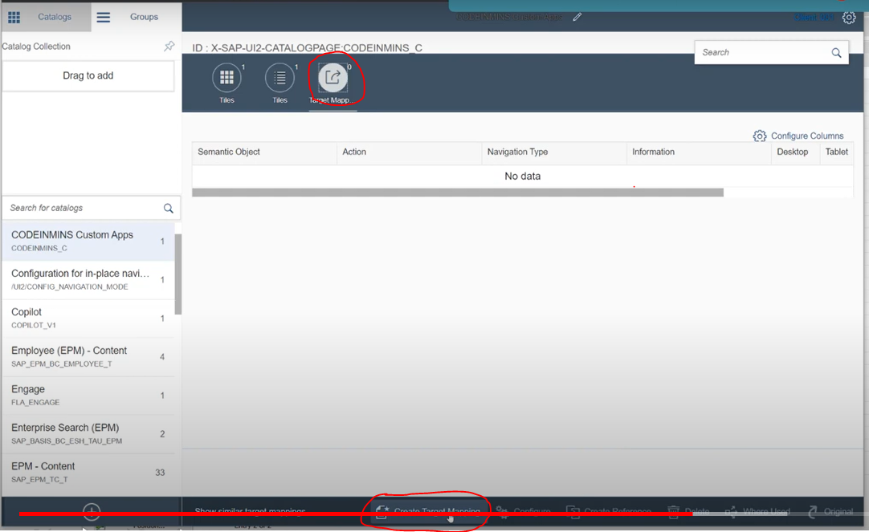

for url in target mapping go to :sicf node --> select the your app --> click on test service --> you will get the url.

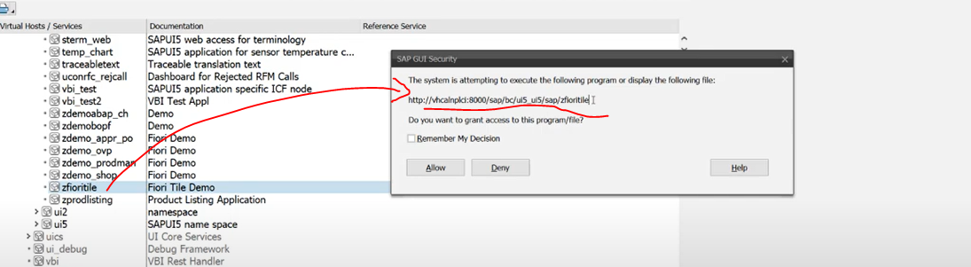

take the url as /sap/bc/ui5_ui5/sap/zfioritile( copy it)

id :- go to webapp-->open controller -->select the id.

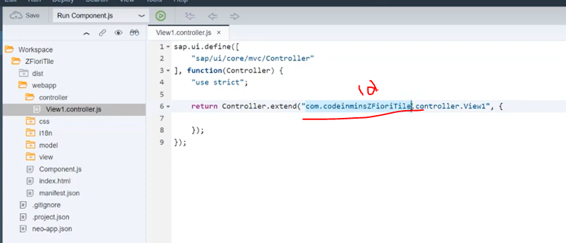

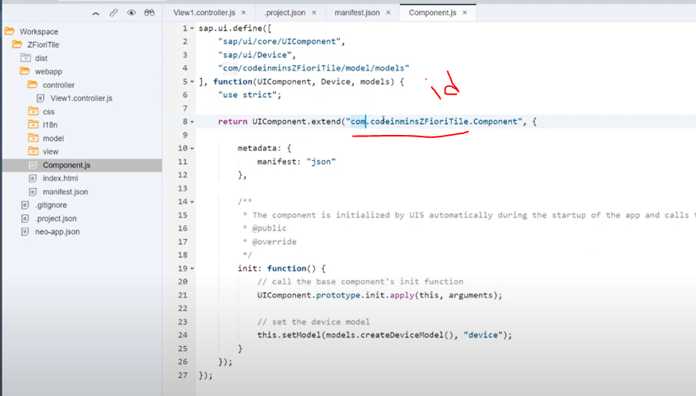

copy it

now use the url/id in target mapping

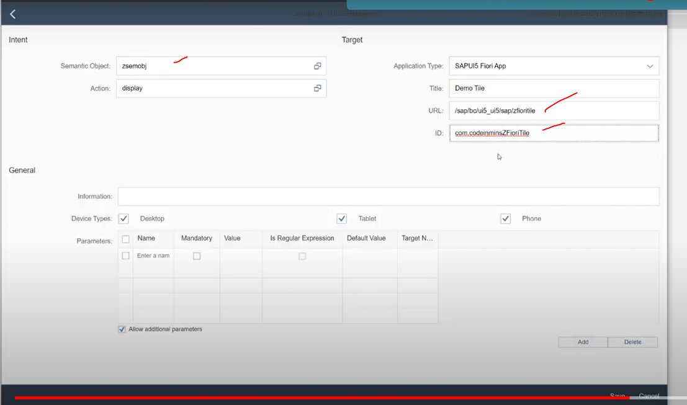

Now target mapping done and our tile created.

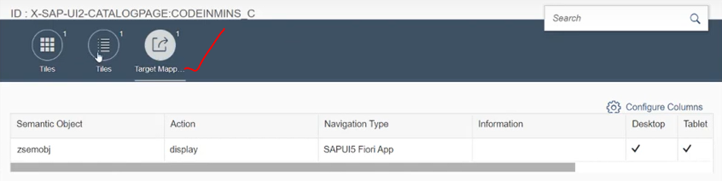

## Now add our tile to group here

Create a group --> click on group tab

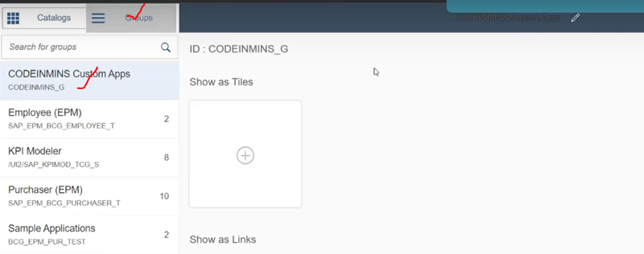

click on + button right side..

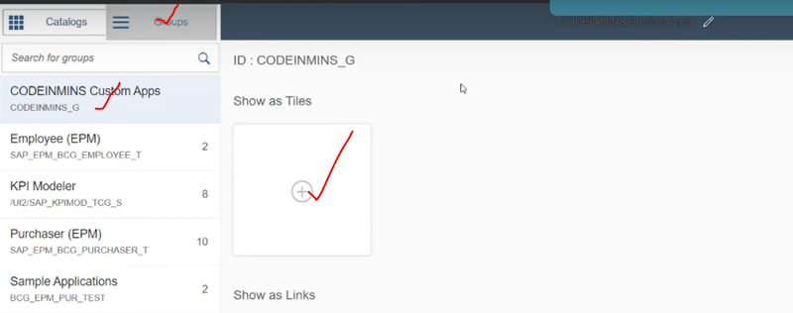

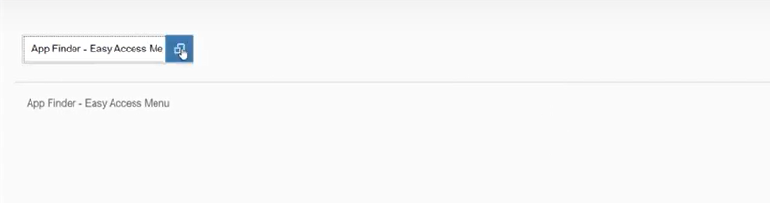

and find the catalogue

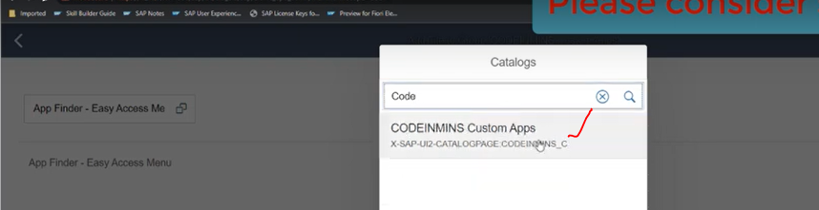

selected the our catalogue.

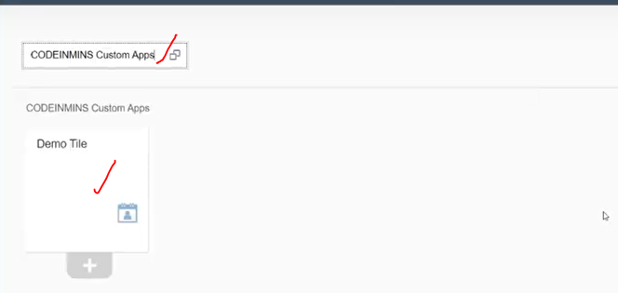

Now click on + button--> to add our tile to group.

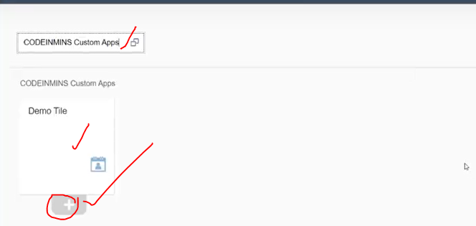

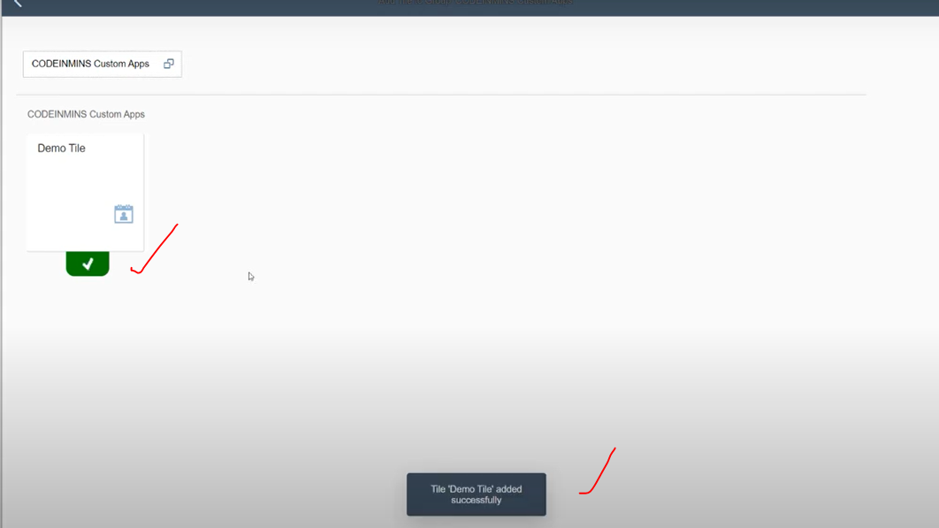

Now tile has been added to the group.

now go back.. when you go back you will c new tile available here....

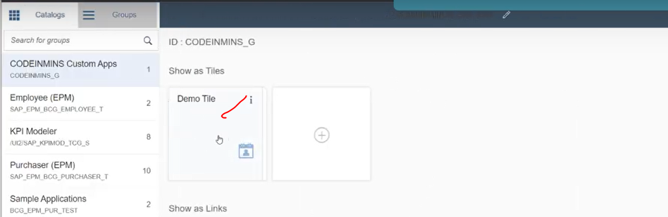

these steps needed to configure the tile to the fiori launchpad.

## Next configuration of the role and assign to the user

PFCG tcode - create the role

created role :ZUI5APSS

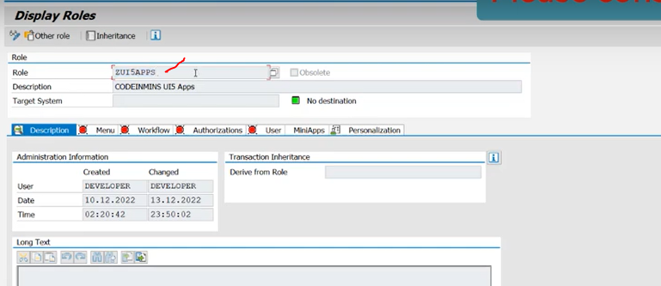

Now we will add the group and catalog inside the role.

Edit the role.--> go to MENU options.

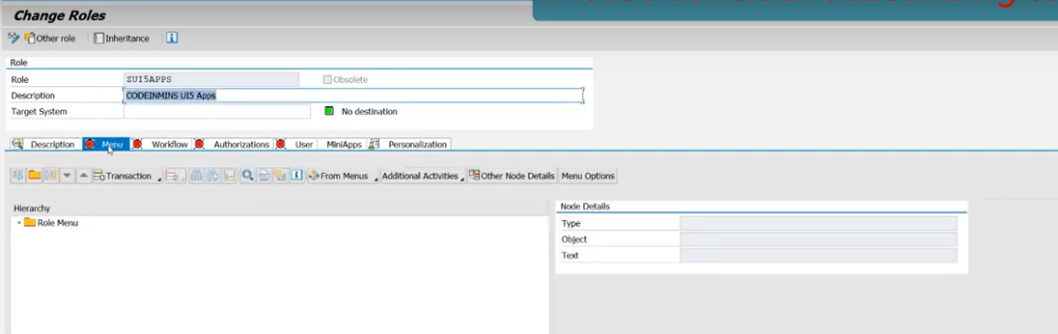

Now click on transaction button --> you will see SAP fiori UI5 Tile catalog/Group

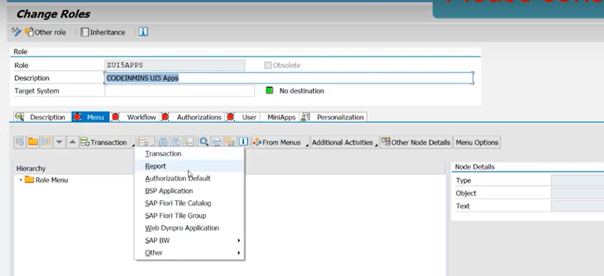

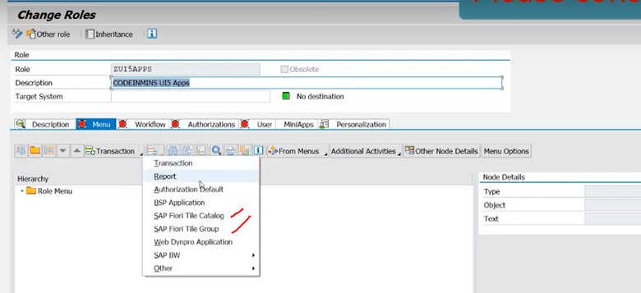

add catalogue --> click on Fiori TIle Catalog--> click on ok.

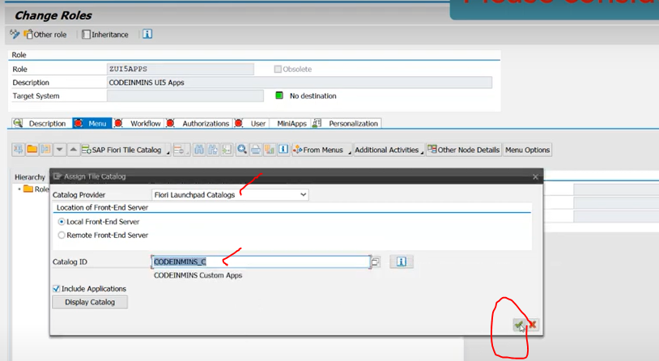

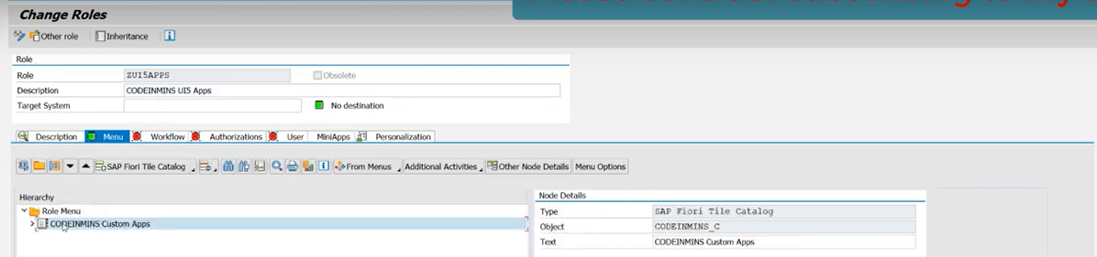

Now catalogue available now.

Now add the group to role.

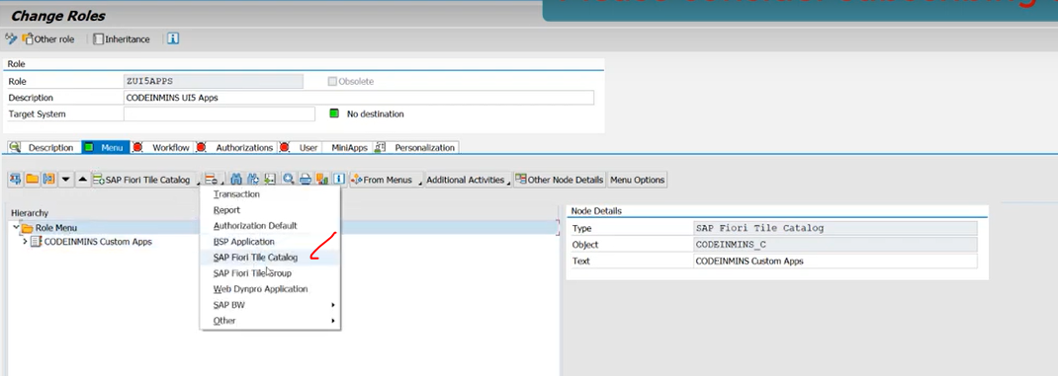

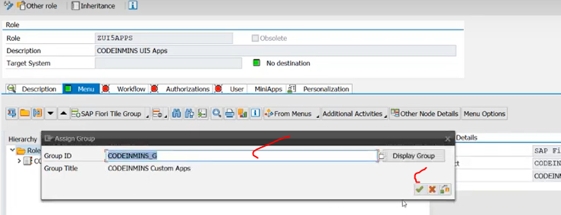

Now we have added the catalogue/groups

Now assign the role to the users. means these catalogue/group assigning to the user--> then only user can able to see the tile.

Now run the Fiori Launchpad --> check it are you getting the tile or not...

Now you can't able to see the any group fiori launch pad.

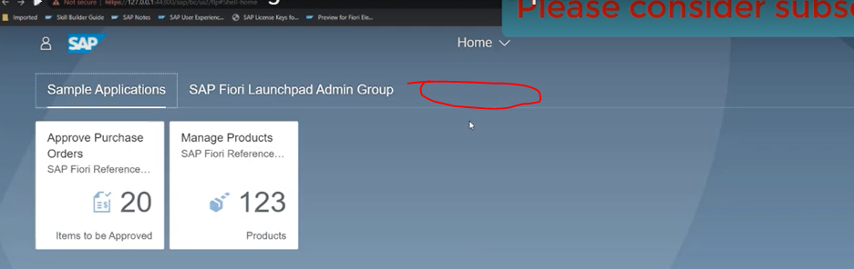

Now assign the role to the user

in pfcg open the role and edit it..--> click on user

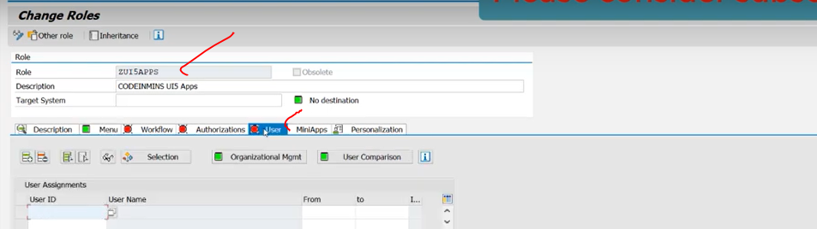

Now assign the user and click on save.

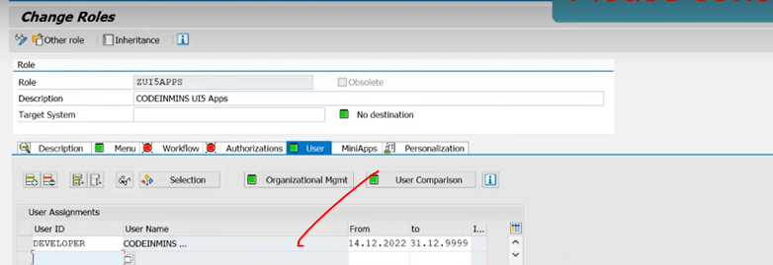

Now go back our fiori launchpad --> check it user added or not..

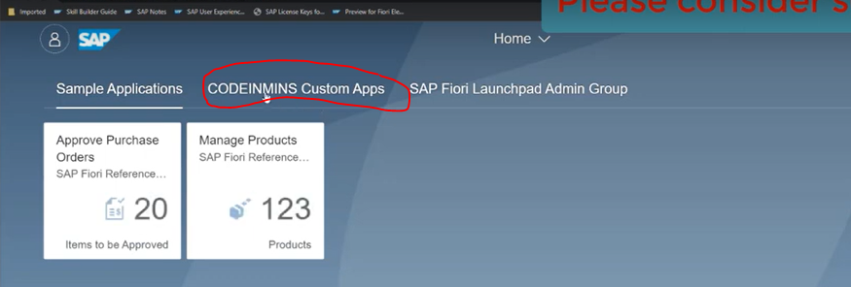

added the group and tile.

